# 

# General simple white cover ranged left + document info panel

|  |  |
| --- | --- |
| Author: | Bryan Sutton, Webcertain |
| Date: | 25 March 2018 |
| Client: | Bobs Burgers |



## This is used for general documents

There are many variations of passages of Lorem Ipsum available, but the majority have suffered alteration in some form, by injected humour, or randomised words which don't look even slightly believable. If you are going to use a passage of Lorem Ipsum, you need to be sure there isn't anything embarrassing hidden in the middle of text.

### Subheading here

There are many variations of passages of Lorem Ipsum available, but the majority have suffered alteration in some form, by injected humour, or randomised words which don't look even slightly believable. If you are going to use a passage of Lorem Ipsum, you need to be sure there isn't anything embarrassing hidden in the middle of text. All the Lorem Ipsum generators on the Internet tend to repeat predefined chunks as necessary, making this the first true generator on the Internet. It uses a dictionary of over 200 Latin words, combined with a

## These headings are Lato Black 20pt

There are many variations of passages of Lorem Ipsum available, but the majority have suffered alteration in some form, by injected humour, or randomised words which don't look even slightly believable. If you are going to use a passage of

### This is a subheading

Lorem Ipsum, you need to be sure there isn't anything embarrassing hidden in the middle of text. All the Lorem Ipsum generators on the Internet tend to repeat predefined chunks as necessary, making this the first true generator on the Internet. It uses a dictionary of over 200 Latin words, combined with a handful of model sentence structures, to generate Lorem Ipsum which looks reasonable. The generated Lorem Ipsum is therefore always free from repetition, injected humour, or non-characteristic words etc.

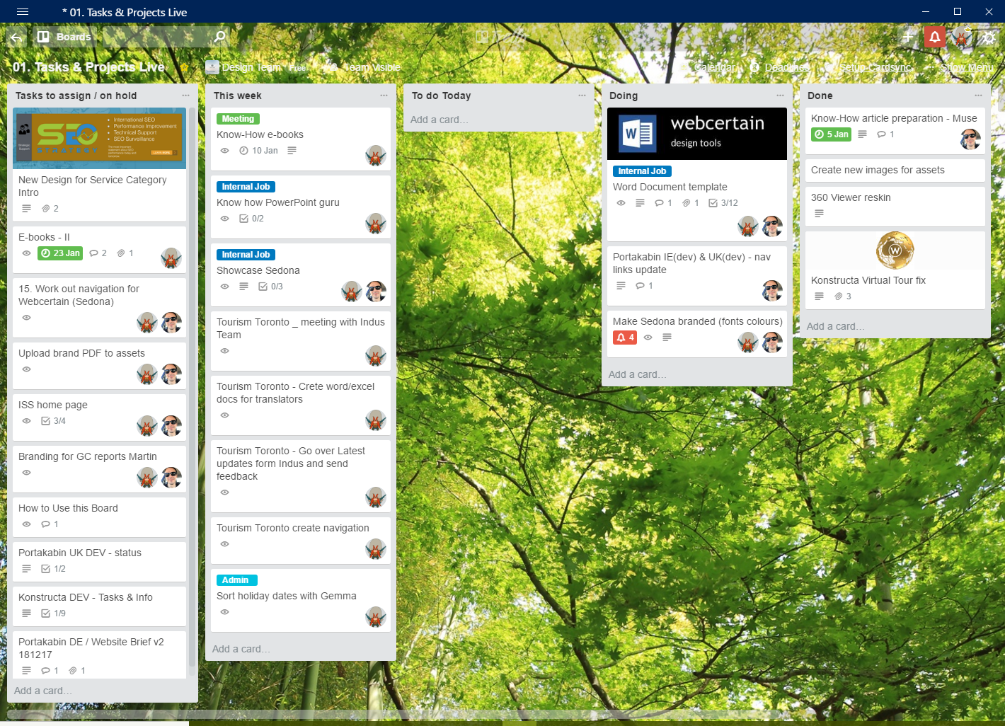

##### Images and descriptions are always centred like this.

Lorem Ipsum which looks reasonable. The generated Lorem Ipsum is therefore always free from repetition, injected humour, or non-characteristic words etc.Praesent magna justo, vulputate a imperdiet sed, rhoncus sit amet arcu.

There are many variations of passages of Lorem Ipsum available, but the majority have suffered alteration in some form, by injected humour, or randomised words which don't look even slightly believable. If you are going to use a passage of Lorem Ipsum, you need to be sure there isn't anything embarrassing hidden in the middle of text. All the Lorem Ipsum generators on the Internet tend to repeat predefined chunks as necessary, making this the first true generator on the Internet. It uses a dictionary of over 200 Latin words, combined with a handful of model sentence structures, to generate Lorem Ipsum which looks reasonable. The generated Lorem Ipsum is therefore always free from repetition, injected humour, or non-characteristic words etc.



##### Small pictures should be centred like this.

All the Lorem Ipsum generators on the Internet tend to repeat predefined chunks as necessary, making this the first true generator on the Internet. It uses a dictionary of over 200 Latin words, combined with a handful of model sentence structures, to generate Lorem Ipsum which looks reasonable. The generated Lorem Ipsum is therefore always free from repetition, injected humour, or non-characteristic words etc. Latin words, combined with a handful of model sentence structures, to generate Lorem Ipsum which looks reasonable. The generated Lorem Ipsum is therefore always free from repetition, injected humour, or non-characteristic words etc.

### Bullet point example

This is what bullet points look like:

* There are many variations of passages of Lorem Ipsum
* available, but the majority have suffered alteration in some form,
* by injected humour, or randomised
* words which don't look even
* slightly believable. If you are going to use a
* passage of Lorem Ipsum

The generated Lorem Ipsum is therefore always free from repetition, injected humour, or non-characteristic words etc.

Numbered or lettered lists look like this:

1. There are many variations of passages of Lorem Ipsum
2. available, but the majority have suffered alteration in some form,
3. by injected humour, or randomised
4. words which don't look even
5. slightly believable. If you are going to use a
6. passage of Lorem Ipsum

The generated Lorem Ipsum is therefore always free from repetition, injected humour, or non-characteristic words etc. The generated Lorem Ipsum is therefore always free from repetition, injected humour, or non-characteristic words etc

#### Heading 4 is a decorative heading for limited use only

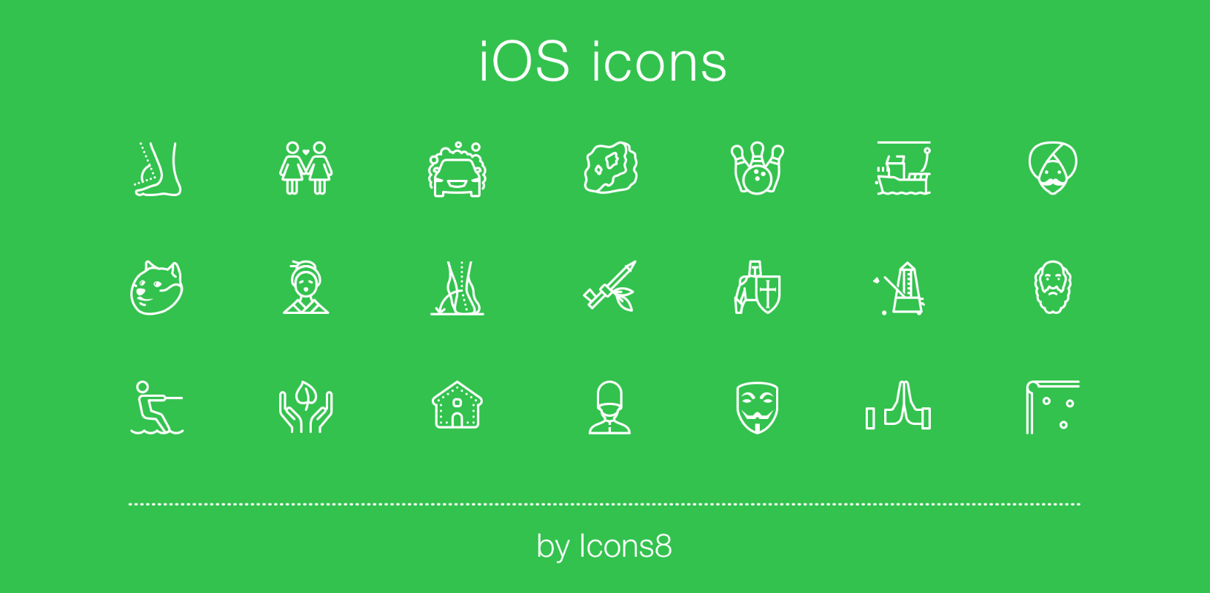Combined with a handful of model sentence structures, to generate Lorem Ipsum which looks reasonable. The generated Lorem Ipsum is therefore always free from repetition, injected humour, or non-characteristic words etc.

##### Oversized pictures look like this – always centred!

There are many variations of passages of Lorem Ipsum available, but the majority have suffered alteration in some form, by injected humour, or randomised words which don't look even slightly believable. If you are going to use a passage of Lorem Ipsum, you need to be sure there isn't anything embarrassing hidden in the middle of text.

All the Lorem Ipsum generators on the Internet tend to repeat predefined chunks as necessary, making this the first true generator on the Internet

# If you are starting a new section or chapter

## Make sure to follow this layout

When creating a new chapter (section) be sure to use the page break function in Microsoft Word: **[File > Pages > ‘Page Break’].**

There are many variations of passages of Lorem Ipsum available, but the majority have suffered alteration in some form, by injected humour, or randomised words which don't look even slightly believable. If you are going to use a passage of Lorem Ipsum, you need to be sure there isn't anything embarrassing hidden in the middle of text.

All the Lorem Ipsum generators on the Internet tend to repeat predefined chunks as necessary, making this the first true generator on the Internet. It uses a dictionary of over 200 Latin words, combined with a handful of model sentence structures, to generate Lorem Ipsum which looks reasonable. The generated Lorem Ipsum is therefore always free from repetition, injected humour, or non-characteristic words etc

There are many variations of passages of Lorem Ipsum available, but the majority have suffered alteration in some form, by injected humour, or randomised words which don't look even slightly believable. If you are going to use a passage of Lorem Ipsum, you need to be sure there isn't anything embarrassing hidden in the middle of text.

.

## Duis sollicitudin porttitor massa sit amet condimentum.

All the Lorem Ipsum generators on the Internet tend to repeat predefined chunks as necessary, making this the first true generator on the Internet. It uses a dictionary of over 200 Latin words, combined with a handful of model sentence structures, to generate Lorem Ipsum which looks reasonable. The generated Lorem Ipsum is therefore always free from repetition, injected humour, or non-characteristic words etc

There are many variations of passages of Lorem Ipsum available, but the majority have suffered alteration in some form, by injected humour, or randomised words which don't look even slightly believable. If you are going to use a passage of Lorem Ipsum, you need to be sure there isn't anything embarrassing hidden in the middle of text.